HR Management System – Data Dictionary

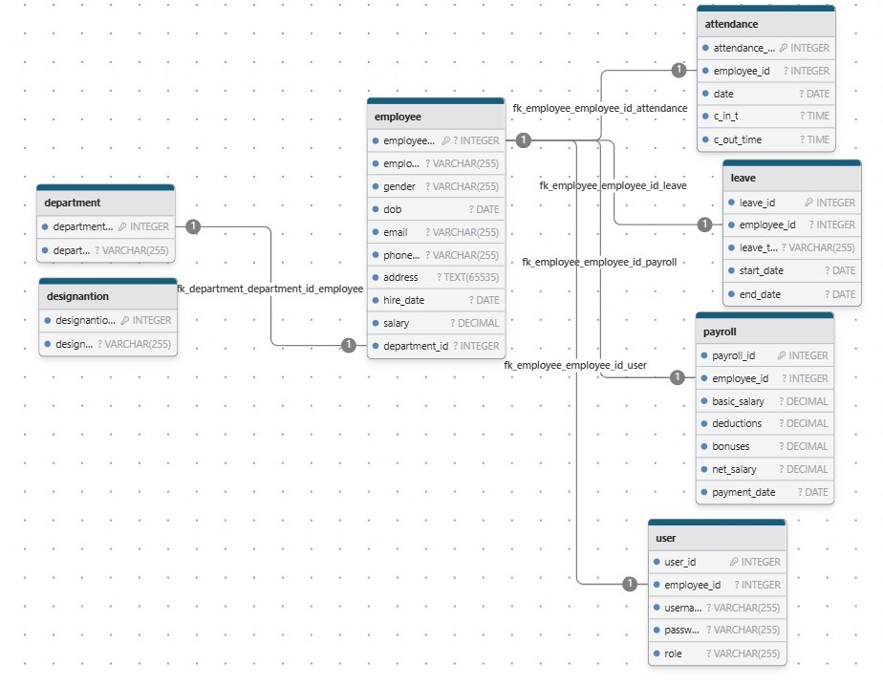

HR Management System – ER Diagram
email
dob
E_name
E_id
P_no
address
has
H_date
1 n
employee
A_id
1
salary
E_id
attendance
D_id
date
1
C_out
gender
C_in_time
payment
n
P_id
n
leave
L_id
E_id
payroll
B_salary
E_id
deduction
L_type
bonus
E_date
S_date
N_salary

P_date

HR Management System – DFD

0 Level DFD

Login login
HRMS
request responce
HR
Employee

1 Level DFD HR panel

1.0
View and manage employee

employee detail employee_detail
HR-panel
5.0
Manage payroll

employee detail
2.0
View and manage attendance

attendence_details attendance_detail
attendence_details
3.0
Report and mange leave

Leave_data
Leave_data leave_data

4.0
Manage project

project_data
project_data project_data

payroll_data
payroll_data payroll_data

1 Level DFD Employee panel

1.0
View employee

employee datail employee_data
Employee

employee detail
2.0
View attendance

attendence_details attendence_data
attendence_details
3.0
Leave application

Leave_data
Leave_data leave_data

4.0
Apply payment recipt
re

payroll_data
payroll _data payroll_data

